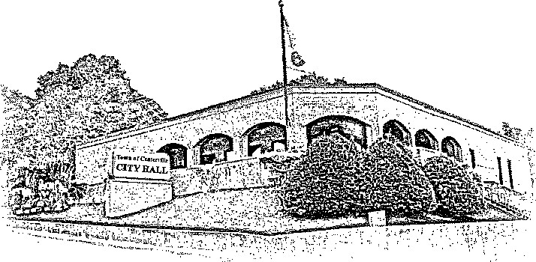 TOWN OF CENTERVILLE

102 EAST SWAN STREET, CENTERVILLE, TN

March 24th, 2025

To: The Board of Zoning Appeals.

Member,

There will be a Board of Zoning Appeals meeting on Thursday, April 10th, 2025, at 4:30pm at City Hall. On the agenda is the following.

1. Meeting called to order.
2. Roll call.
3. Reading and approval of the minutes of the previous meeting.
4. Request by Property owner AJ Woods for a Special Exception to have a home occupation on property located at 1205 N. Oak Dr., Centerville, TN 37033 (Map 095C, Group C, Parcel 005.00) Article IV, Section 4.040.
5. Any other business that may arise.
6. Adjournment

Josie Petersen