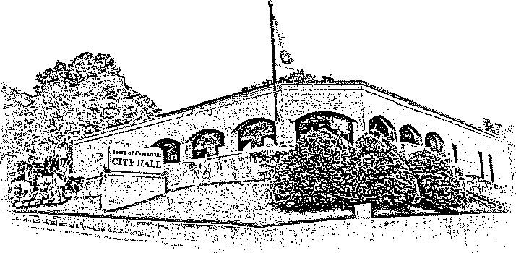
TOWN OF CENTERVILLE

EAST SWAN STREET, CENTERVILLE, TN 37033

Office of Planning & Zoning (931) 729 – 4246 ext. 111

July 31, 2026

RE: City of Centerville Annexation of 14.58 Acres at 819 Industrial Rd. and 355 Feet of Industrial Rd.
The City of Centerville Municipal Regional Planning Commission met on July 21, 2026, approved the annexation and plan of municipal services for 14.58 acres at 819 Industrial Rd. and 0 Industrial Rd. and a 355 feet section of Industrial Rd. to the boundary of parcel 061.03 as shown on the attached map. Attached is a map of the annexed areas.
Annexed Area:
Hickman County Tax Map 071, Parcel 061.03- 13.28 Acres - 0 Industrial Rd. (Entire property)
Hickman County Tax Map 071, Parcel 059.02 – rest of 1.3 Acres- 819 Industrial Rd. (Partial property)
355 feet section of Industrial Rd. and roadway improvements as per the Plan of Services to the property boundary of Parcel 061.03 as shown on the attached map.
Discussion by the Centerville Board of Mayor and Alderman will be held as follows:
First Reading: September 8th, 2026, at 7:00 PM
Second Reading: October 13th, 2026, at 7:00 PM
Public Hearing: October 13th, 2026, at 7:00 PM
Meeting location: 102 E. Swan St., Centerville, TN 37033 in the courtroom.
If you have any questions, give me a call at (931) 729-4246 ext. 111
Sincerely,
____________________________________
Josie Petersen
City of Centerville Planning Director

