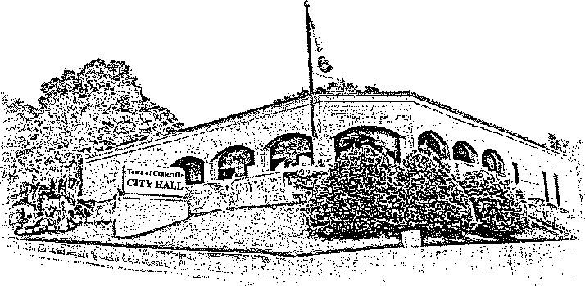
TOWN OF CENTERVILLE

EAST SWAN STREET, CENTERVILLE, TN 37033

Office of Planning & Zoning (931) 729 – 4246 ext. 111

Municipal Annexation Report

Applicant: Duncan & Grove LLC

Date: June 26, 2026

Property Owner: Duncan & Groves LLC

Tax Map/Parcel: Map 071, Parcel 061.03 - 0 Industrial Rd. (13.28 acres) and Map 071, Parcel 059.02 - 819 Industrial Rd (remainder of 1.3 acres)

Property Address: 0 Industrial Rd and 819 Industrial Rd., Centerville, TN 37033

Acreage: 14.58 Acres

Current Zoning: A-1 Agricultural/I-2 Heavy Industrial

Requested City Zoning: I-1 Light Industrial

Purpose of Request
The property owner has submitted a petition for voluntary annexation into the corporate limits of the Town of Centerville for the purpose of constructing multiple industrial warehouse buildings to support the manufacturing of playground equipment. Concurrent with annexation, the applicant requests that the property be zoned I-1 Light Industrial.

Property Description
The subject property is located along Industrial Road immediately adjacent to the existing corporate limits of the Town of Centerville. The two parcels in total of 14.58-acres are currently vacant agricultural land and occupied Heavy Industrial property and is traversed by a natural gas transmission pipeline that occupies a significant portion of the property. The property is contiguous to the existing municipal boundary.

Surrounding land uses include:

Direction Existing Use
North Vacant Agricultural land with natural gas pipeline
South Grandfathered Heavy Industrial (Hickman County Landfill)
East Existing Light Industrial development
West Vacant Agricultural & Residential Properties

Annexation Eligibility
The proposed annexation meets the following criteria:

Property is contiguous to the existing municipal boundary.
Annexation is consistent with the Urban Growth Boundary.
Property owner has petitioned for annexation.
Municipal services can reasonably be extended.

Municipal Services
Upon annexation, the Town intends to provide the following services:

Service Provider
Police Protection Town of Centerville Police Department
Fire Protection Town of Centerville Volunteer Fire Department
Water Town of Centerville Water Department
Sewer Town of Centerville Wastewater Department
Solid Waste Collection Town of Centerville Collection
Street Maintenance Town of Centerville Public Works
Planning & Zoning Town of Centerville

Utility extensions, if necessary, shall be completed at the developer's expense unless otherwise approved by the Board of Mayor & Alderman.

Consistency with Growth Plan
The subject property lies within the Town's designated Urban Growth Boundary and is identified for future municipal expansion in the adopted growth plan.

Annexation is consistent with the goals of:
Orderly and planned growth
Efficient delivery of municipal services
Coordinated infrastructure planning
Zoning Recommendation
Appropriate industrial development within designated growth areas

Staff recommends zoning the property I-1 Light Industrial immediately upon annexation because:
The proposed use is compatible with adjacent Industrial development.
Public water, gas, and sewer are available.
The zoning is consistent with the Town's Future Land Use Map.
Fiscal Impact
Estimated Revenue
Property Taxes
Building Permit Revenue
Utility Revenue
Local Sales Tax (indirect)

Estimated Costs
Police patrol
Fire protection
Street maintenance (future dedication)
Utility maintenance

Staff anticipate the long-term fiscal impact will be positive upon completion of the development.

Public Infrastructure
Road access will be from Industrial Road.

The development will be required to comply with all Town Zoning, Subdivision, & Development Regulations:

Staff finds:
The property is contiguous to the Town limits.
Annexation is consistent with the adopted Growth Plan.
Municipal services can be provided in a timely manner.
The proposed zoning is compatible with surrounding development.
Annexation promotes orderly municipal growth.
Planning Staff recommendations:
Approval of the annexation request including 355 section of Industrial Rd.
Approval of Plan of Services
Approval of the requested I-1 zoning effective upon annexation.
Approval subject to all applicable Zoning, Subdivision and Development Regulations.

Prepared by:
Town of Centerville Planning & Zoning Director Josie Petersen

Attached exhibits:

Legal Description
Annexation Map
Plan of Services

